Celebrating the launch of Leicester’s Speech and Language Therapy Centre

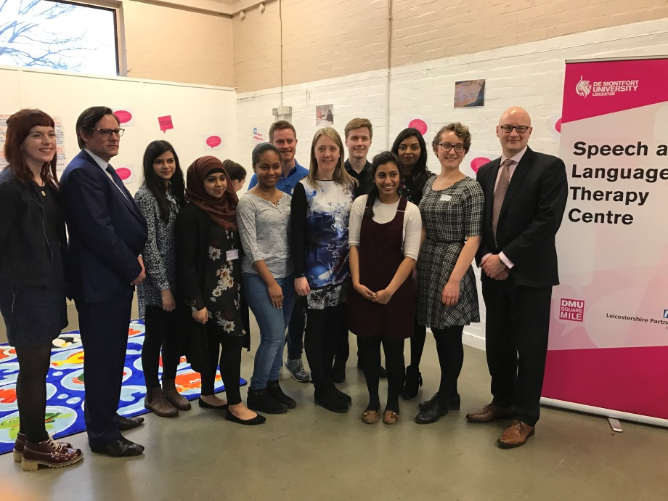
A celebration event was held on Tuesday 28th February 2017 to officially launch the Speech and Language Therapy Centre based at Leicester’s Centre for Integrated Living. The provision has been developed thanks to a partnership between Leicestershire Partnership NHS Trust (LPT) and De Montfort University (DMU) #DMUlocal, and ensures that speech and language therapy students are supported to gain hands-on clinical experience during their placements while enhancing local speech and language services. Being based at the LCIL gives students the opportunity to understand the wider perspective of health social care and link with local resources.

Professor Adrian Childs, LPT chief nurse and deputy chief executive is pictured second from left with DMU speech and language students, children’s speech and language therapist Idalina Rodrigues (third from right), and Simon Oldroyd, dean of the Health and Life Sciences faculty at DMU.

Two LPT speech and language therapists have been seconded to DMU to support the project. Their role is to mentor students during placements in the heart of the community, thereby enhancing community links and neighbourhood working. Over the last academic year, students have supported 19 people with dementia and their carer. both in care homes and at the centre. 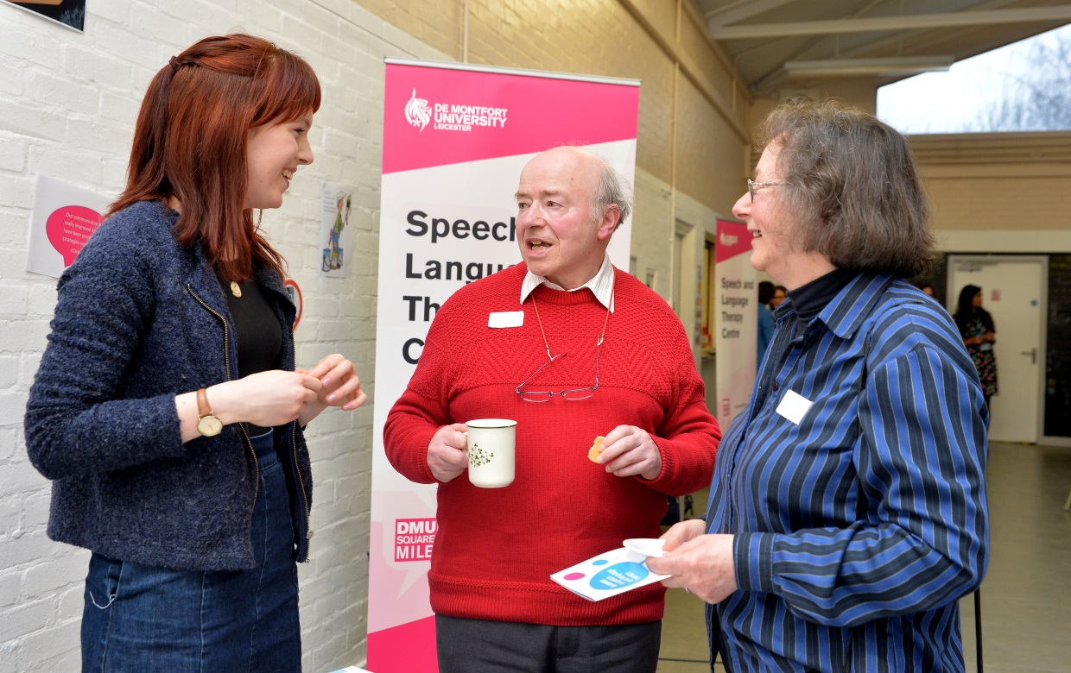
Mr Gill – diagnosed with frontotemporal dementia – said he had been helped by Rosie Davies, a fourth year Speech and Language Therapy student on a placement at the centre. He said: “One of the things that happens with my condition is a decline in vocabulary and speech does become more and more difficult over time.
“We had weekly sessions over six weeks with Rosie, who showed how to ask a partner for help in finding a specific word, so we have a list of suggestions on how to find the right word, how to describe it, how to search for it.
“At each and every visit there was something that I just hadn’t thought of which was useful.
“Rosie was actually only a student, but I could easily imagine her in a clinical setting where she would have full authority because that’s what she came across to me as – somebody who knew exactly what she was talking about and had the right techniques and skills.”

Students have also worked with 25 pre-school children identified as having delayed language acquisition or other speech needs.

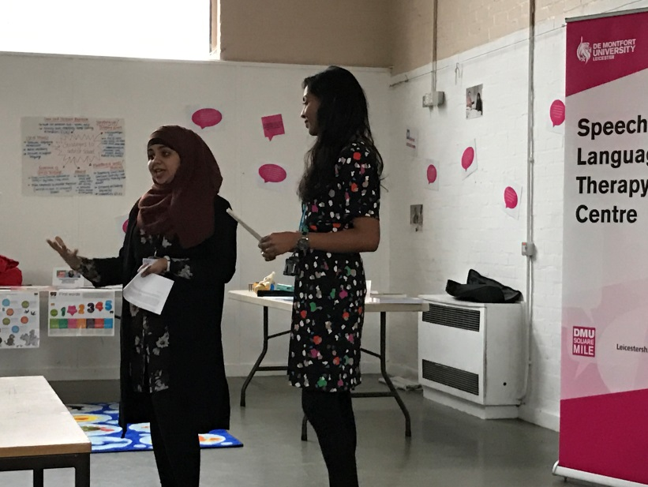
At the event, children’s speech and language therapist Idalina Rodrigues, pictured with student Shagufta Ghumra, presented the work her students had been doing across three pre-school settings and at the LCIL. Shagufta said: “It’s been fantastic to have the opportunity to make informed clinical decisions, and it’s really helped me grow in confidence.”

Professor Adrian Childs, LPTs chief nurse and deputy chief executive, said: “These placements provide a great opportunity for speech and language therapy students to experience neighbourhood working right in the heart of the community.”

