BSc Nursing:
Process for checking completion of electronic Practice Assessment Document (ePAD) on nursing placements

This guide gives students and their assessors instructions on how to ensure required elements are completed in the electronic Practice Assessment Document (ePAD) at the start, middle and end of a placement.

The majority of the ePAD documentation can be found under the student’s relevant Part. Usually, the Part corresponds to the Year of Study: First year students are in Part 1, etc. It will be labelled with the red notification Current.

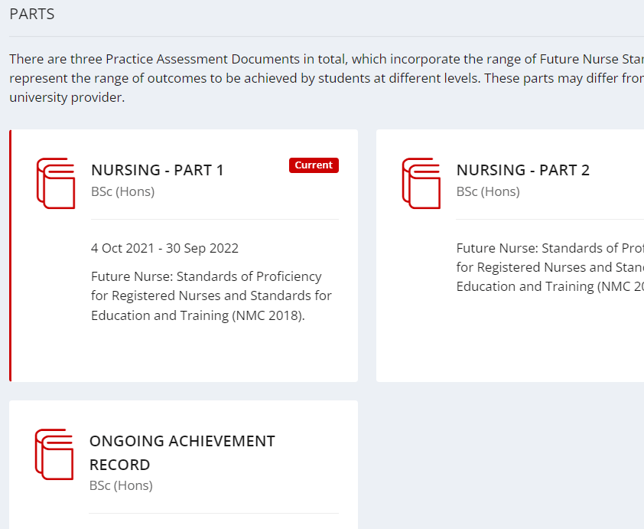

NB: do not assume that the red notification ‘completed’ means the form has been completed fully and correctly. This notification appears as soon as a form has been commenced. Open the forms to check that all fields are complete.

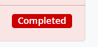

Actions for the start of the placement
Open the Start tab and ensure that each section has been completed:
- Practice Assessor Allocation
- Practice Supervisor (PS) Allocation (this may be updated throughout the placement)
- Placement Orientation
- Initial Interview

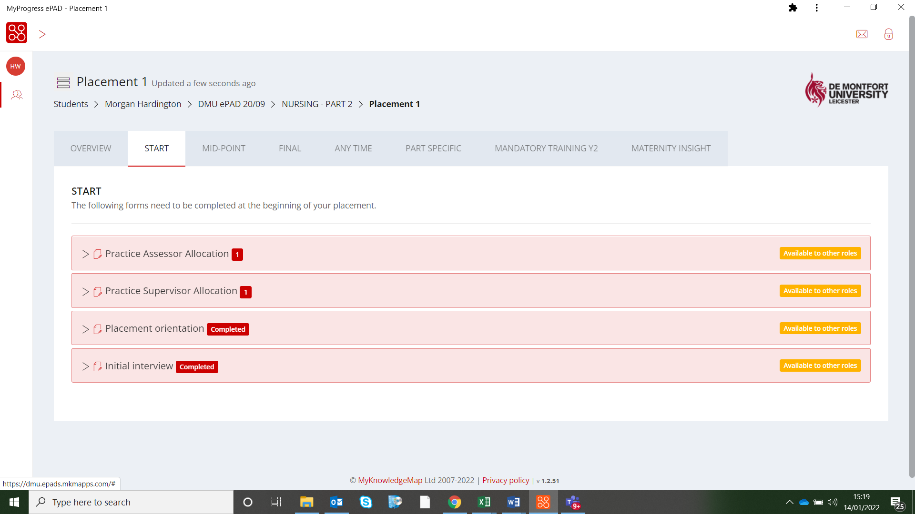

Actions for the midpoint
Open the ‘Mid-point’ tab. It is located next to the start tab and ensure each tab within it has been completed:
- Mid-point interview (sections available to students and to the PS/PA).
- Professional Values in Practice. If the PA/PS has clicked ‘no’ for any of these points, an action plan must be completed.
- Usually it will be the PA that completes the midpoint interview. If the PA is unavailable, then a Practice Supervisor can complete the interview and feed back to the PA at the first opportunity.

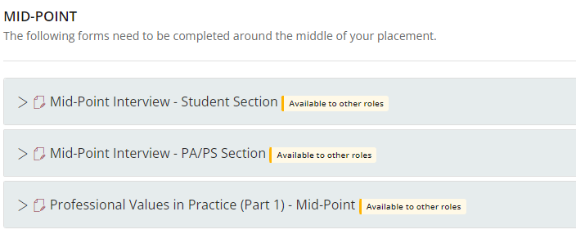

Actions for the final interview
In the ‘Final’ tab:
- Ensure ALL FOUR items have been carried out and completed.
- This must be completed by the submission date for each placement. This is usually a few days after the end of the placement block to allow for unexpected delays.
- Each section is available for the Student, PA, or both to complete.
- The fifth form, Practice Placement Evaluation, should be completed by the student once the placement has ended. This feedback will be anonymised and sent to the placement provider in batches at a later date.

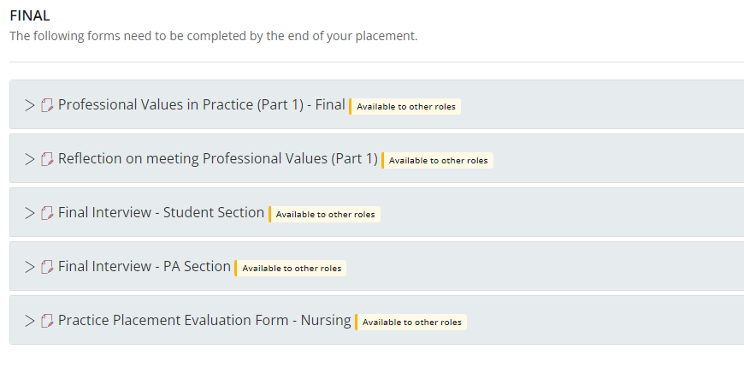

In the ‘Any Time’ section:

- There should be TWO patient/carer/service user feedback forms completed per placement. If not completed in the current placement, the student will need to seek additional feedback to ensure that the student has the correct amount for each year.
- Review the Practice Learning Log and Record of Working With and Learning From Others/Inter-professional Working have been completed if agreed in the initial interview.
- ‘Record of Communication/Additional Feedback’ and ‘Change of Placement’ may be completed in individual circumstances.
- The Cause for Concern form should be used when the practice area are concerned with a student’s conduct and have not been able to resolve the issues internally.
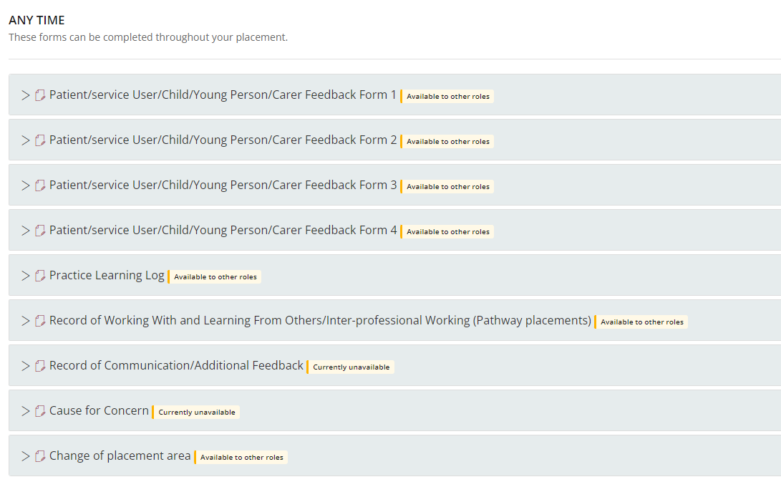

In the Part Specific tab:

- Check Assessment of Proficiencies and complete all that have been achieved in each placement. These must be achieved by the end of each Year, so assess them in each placement to ensure ample opportunity to complete them.
- The Action Plan is used for when students need additional support to meet Professional Values or Proficiencies. Speak to your Practice Learning Team or your student’s Academic Assessor for assistance in completing this when necessary.
- The Episodes of Care and Medicines Management assessments can be completed at any time during the part. They MUST be completed by the end of the final placement, and can be attempted multiple times.
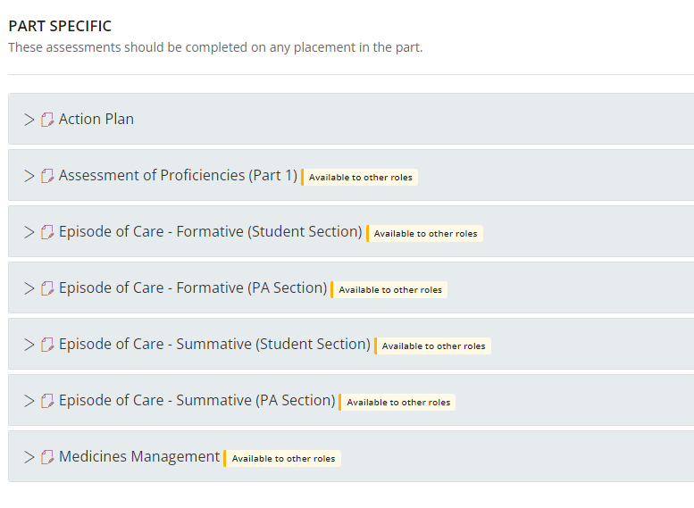

Scroll back to the top of the page to View Timesheets.
- Ensure these have been inputted for the placement.
- Ensure that the correct number of hours have been inputted on the correct dates. Unexplained errors should be escalated to the Academic Assessor urgently.
- Breaks should not be counted.
- Students are permitted up to 2.5 hours per week of self-directed reflection and learning time. This should be evidenced through reflections uploaded to the Reflections section of the ePAD. If insufficient reflections have been uploaded then these hours should not be awarded.
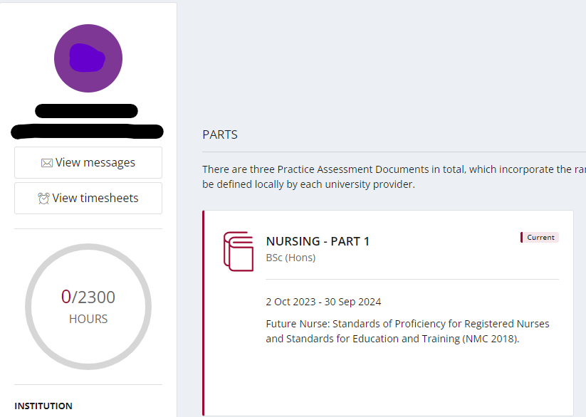

Now complete the Ongoing Achievement Record.
Do this by clicking on the student’s name in the string at the top.
Click on the Ongoing Achievement Record tile.
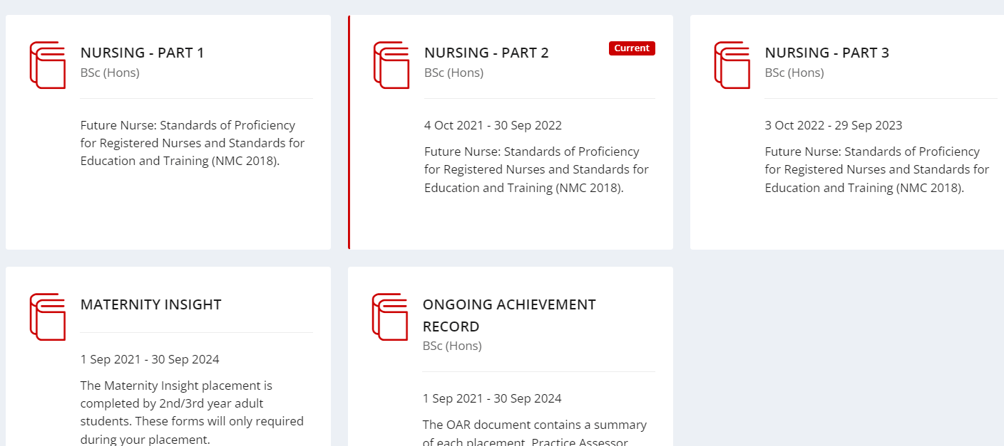
Click on Forms:

- The Practice Assessor should complete the Practice Assessor Checklist for the correct placement.
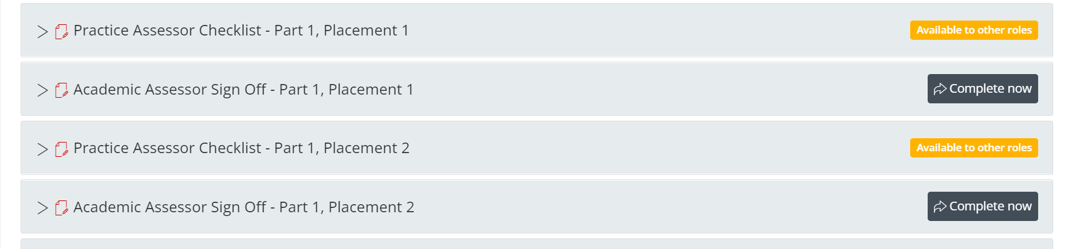

- Please note that for the Final Placement interview in each Part, the PA must also complete the End of Part Approval (Part 1/2/3) form.
- The “Top-Up Placements” usually will not need to be completed.
- PAs can confirm in the Achievement of Proficiencies in either Part 1/2 or Part 2/3 forms, but these may also be achieved in the following year and are therefore not mandatory. Failure to complete these in Part 1 or 2 will not result in a penalty.

COMPLETE – WELL DONE

