Guide to Documenting Proficiencies on the eMORA

* Log into your DMU eMORA account. Please contact the ePAD helpdesk if you are experiencing any difficulties. [epadhelpdesk@dmu.ac.uk](mailto:epadhelpdesk@dmu.ac.uk)
* Find the students name in your list of students.

You may need to change the cohort if you cannot see the student’s name

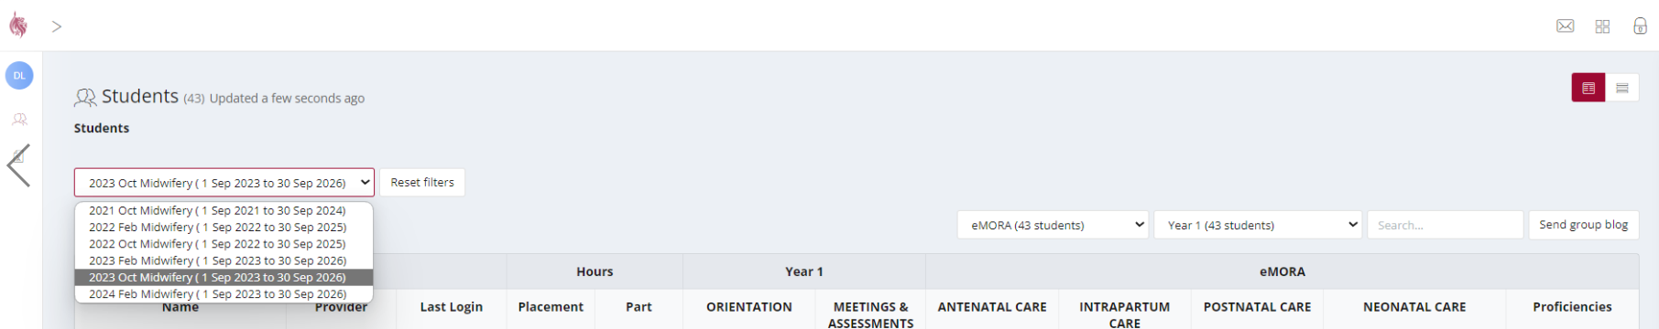

* If the students name is still not in your list, please ensure they have allocated you as a Practice Supervisor and that your email address is correct. They may need to try allocating you a second time.
* Click on the eMORA box
* 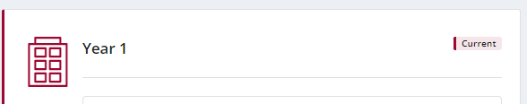Choose the correct year, it will say ”current” in the right hand corner

Choose which section you need to document the achieved proficiencies

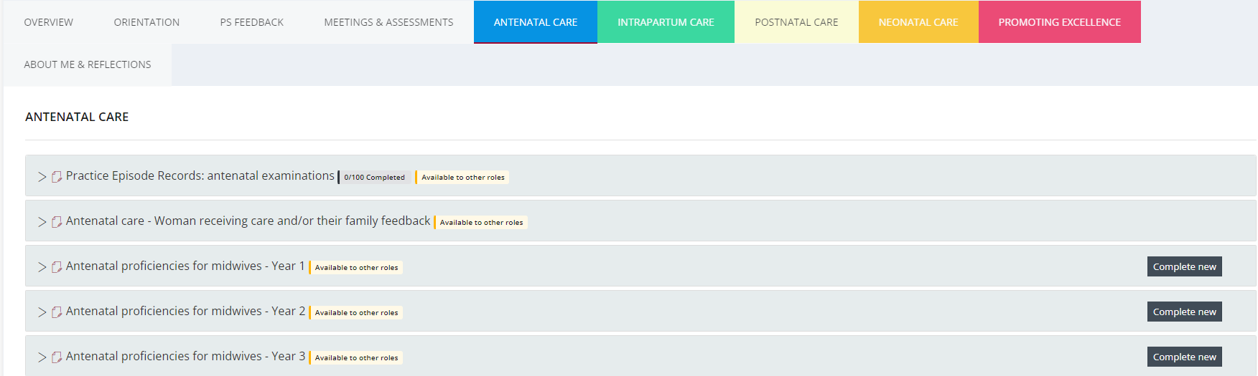

Click the complete new button, ensuring you have the correct year.

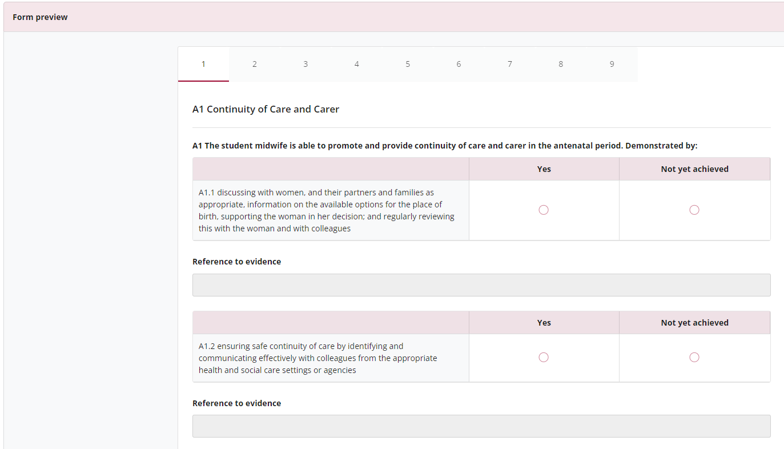

You need to open each tab to see all of the proficiencies

Click achieved

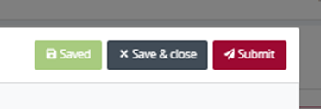

When you have marked all the proficiencies the student has achieved in each tab, click submit. Enter your name and email address when prompted to do so