Guide to Documenting Feedback on the eMORA

* Log into your DMU eMORA account. Please contact the ePAD helpdesk if you are experiencing any difficulties. [epadhelpdesk@dmu.ac.uk](mailto:epadhelpdesk@dmu.ac.uk)
* Find the students name in your list of students.

You may need to change the cohort if you cannot see the student’s name

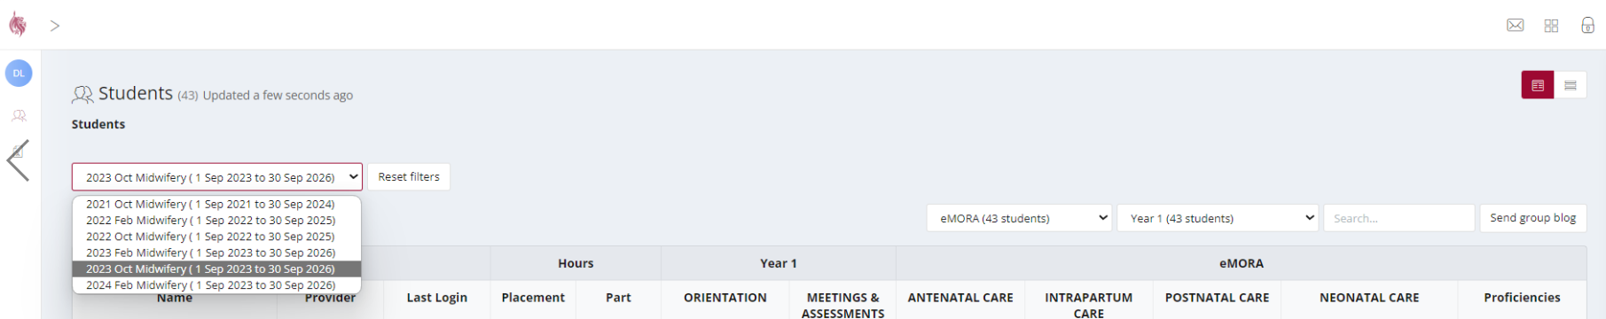

* If the students name is still not in your list, please ensure they have allocated you as a Practice Supervisor and that your email address is correct. They may need to try allocating you a second time.
* Click on the eMORA box
* Choose the correct year, it will say ”current” in the right hand corner

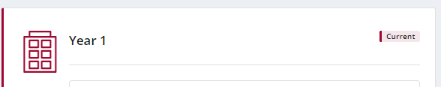

Select PS Feedback

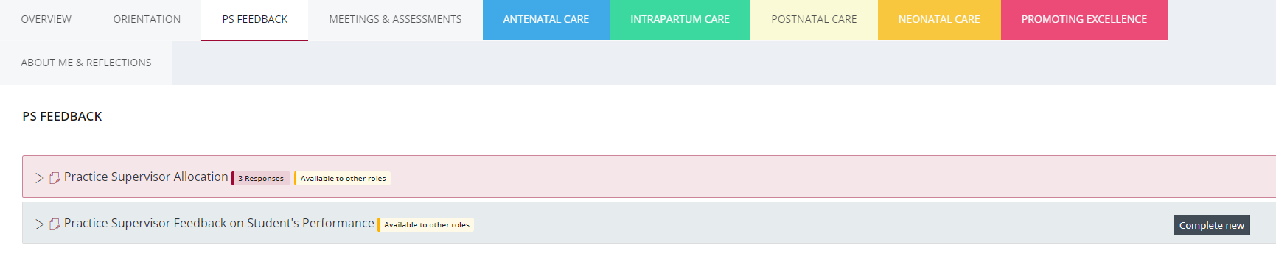

Click on the complete new button of the Practice Supervisor Feedback on Students Performance form.

* Complete all sections of the form, ensure that you enter your name and email address as authorisation when asked to do so.

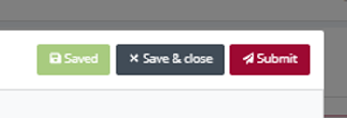

Click submit

* Alternatively the student can access the form through their account. You need to complete it adding your name and email address as authorisation.